Anna Nguyen
June 13, 2025
Exercise # 4
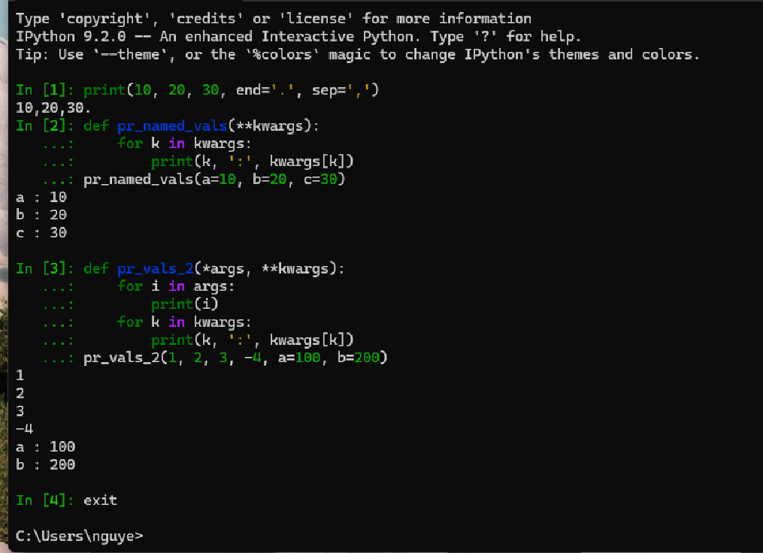

Three Advantages of using the **kwargs (keywords arguments):
- Flexibility in Function or Method Signature:
- No need to predefine every possible parameter a function might accept. These features provide great flexibility when designing functions that need to handle a varying number of inputs.

- Readability:
- By using **kwargs, you can make your code more readable and self-documenting. Instead of having to pass a dictionary of arguments, you can pass them as keyword arguments, which are more intuitive and easier to understand.

- No Order Required with **kwargs:
- When passing arguments using key=value format, their order doesn’t matter, unlike positional arguments.
Three disadvantages of using **kwargs in Python:
- Reduced Code Readability:
- Using **kwargs hides what arguments the function expects. This lack of clarity can make code harder to read and understand.

- No Validation:
- **kwargs accepts any keyword argument, so it is easy to pass invalid or misspelled keys without triggering an error. Risk of runtime errors from missing or extra keys.
- Manually check for required keys and raise clear error if they’re missing.

- Poor IDE support:
- Limited autocomplete, type checking, and refactoring support

